Meshaal Mouawad
Mississippi State University, Electrical and Computer Engineering Department,
This is a summary report of my research assignments I was given by my advisor during my PhD program
Summary Report: week 17
For Research Assignments of my PhD

August 9, 2021

Local points (targets) | X | Y | Node number for TSP
$$p_{1}$$ | 35 | 33 | 0
$$p_{2}$$ | 257 | 233 | 1
$$p_{3}$$ | 424 | 307 | 2
$$p_{4}$$ | 258 | 71 | 3

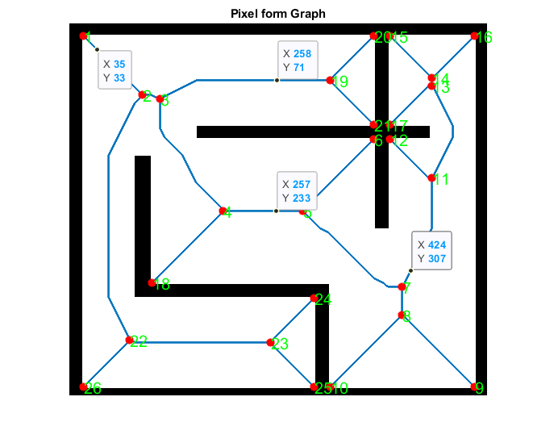
Targets

We used CBC MILP Solver for TSP optimization. The output for the optimal path is:
[(0, 1), (1, 2), (2, 3), (3, 0)

Fig. 2.
The blue line (path) is the Voronoi diagram which will be used to avoid the obstacles.
The small squares are the local points (targets).
The green line is the path that the robot will use to navigate the local points ( the target) using DWA, it will follow the path of the TSP in the order (1, 2, 3, 4) in addition to Voronoi diagram such that the robot will not go directly from target $p_{n3}$ to $p_{n4}$ due the wall between them (even though if it is closer), instead it will follow the path (7 , 6), (6, p_n2), (p_n2, 4), (4 , 2), (2,3), (3, p_n4) as it shows in figure. 2.

